40.48: For a wave function 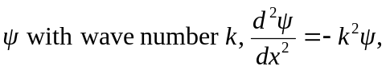 and using this in

